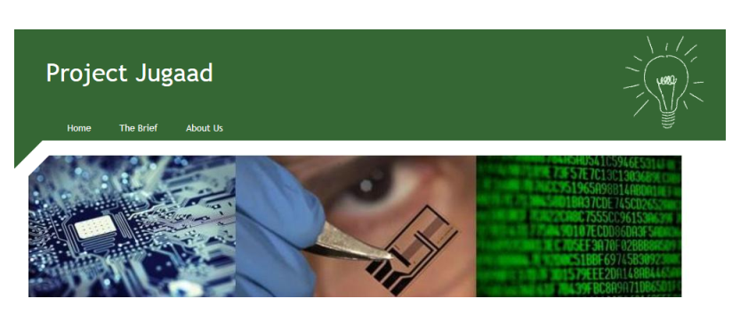

TEAM NAME:
PROJECT MANAGER

CHIEF RESEARCHER

DIGITAL ENGINEER

COMMUNICATIONS DIRECTOR

PROJECT TITLE:
Brief description of Research Project including areas of mathematics involved:
LOGO DESIGN:

